**Create UI for a new canvas app**

1. Log into [Power Apps](https://make.powerapps.com/).
2. On the Home screen select **Canvas app from blank**.

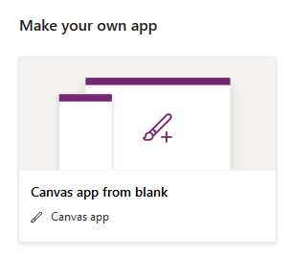

1. Name your app **New UI App** and click **Create**.

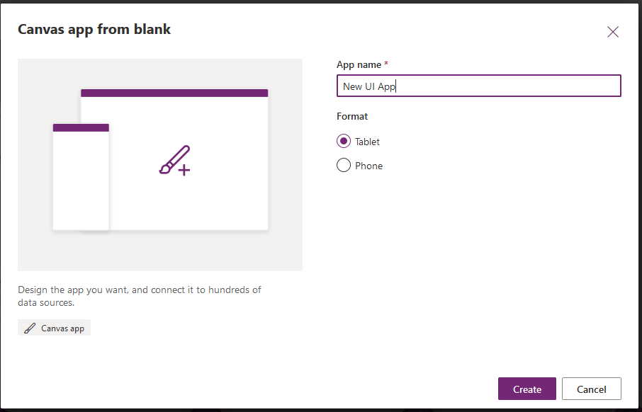

1. In the new app, select the **Insert** tab and the **Icons** dropdown. Scroll close to the bottom of the dropdown options and choose **Rectangle**.
2. Move and resize the rectangle to cover the top of your app screen.

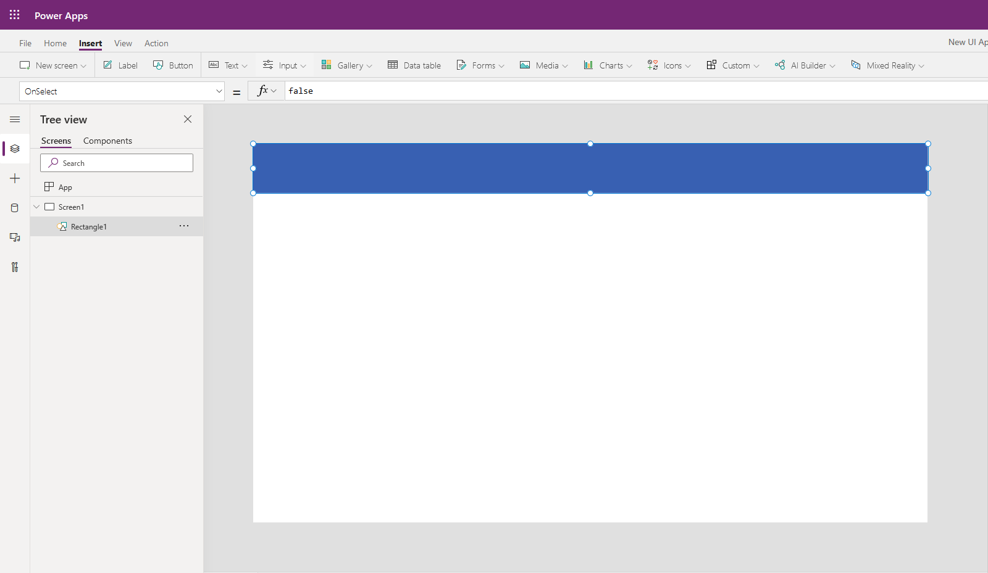

1. Next, select the **Media** dropdown at the top and choose **Image**.
2. Move the image to the top right corner of your app screen.
3. Change the Image property to:

PowerApps FormulaCopy

User().Image

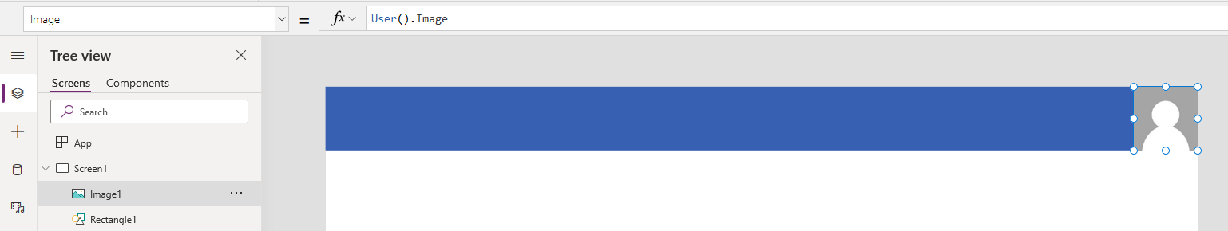

1. Insert a **Label** and change the Text property to:

PowerApps FormulaCopy

User().FullName

1. Move the label next to the image and resize as needed.

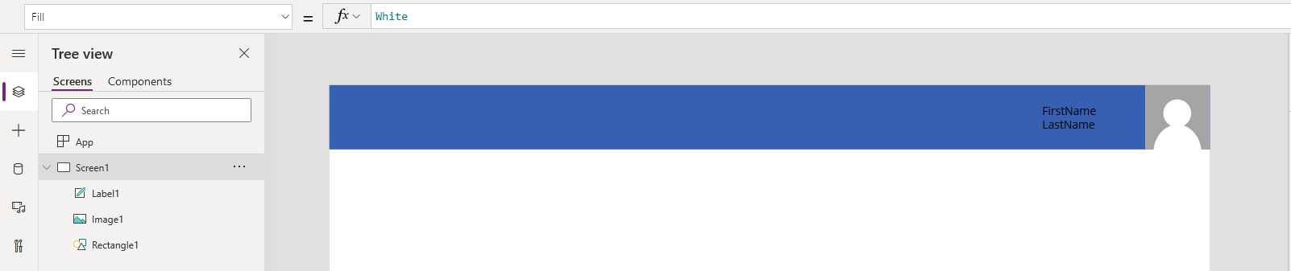

1. Insert a **Button** and move it to the middle of the screen.
2. Select the **Home** tab in the top left, and click the **Theme** dropdown. Choose **Forest**.

